CT417 – Assignment 1

Andrew East

16280042

25 October 2018

Maven Build Automation & Shippable Continuous Integration

# Code Repository for Part A

<https://github.com/reideast/ct417assn1primary>

# Code Repository for Part B

<https://github.com/reideast/ct417assn1secondary>

# Maven Build of Part B

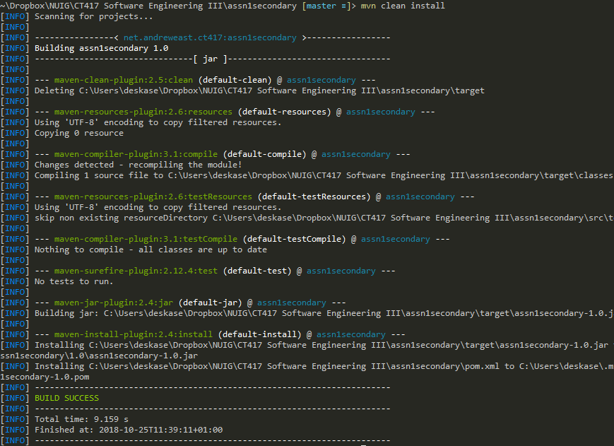

# Test Run of Part A

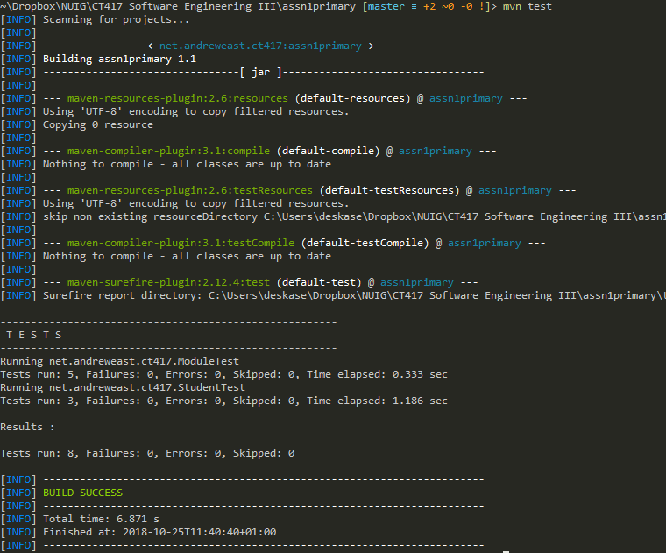

# Console Output of Part B

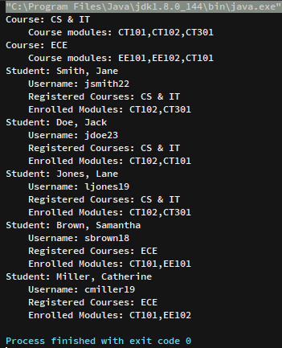

# Local Git Revisions for Part A

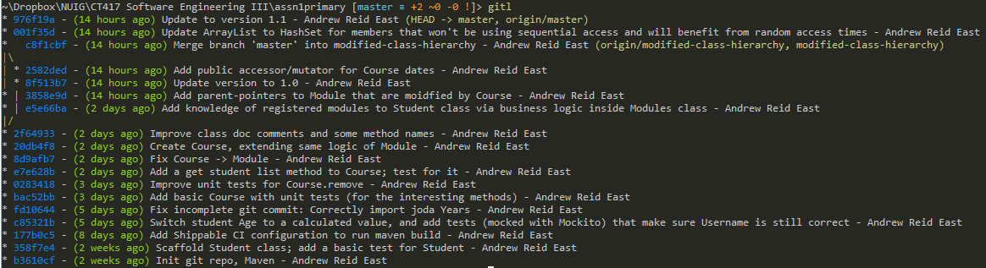

# Local Git Revisions for Part B

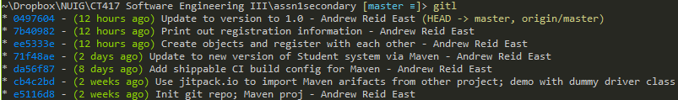

# Shippable Jobs for Part A

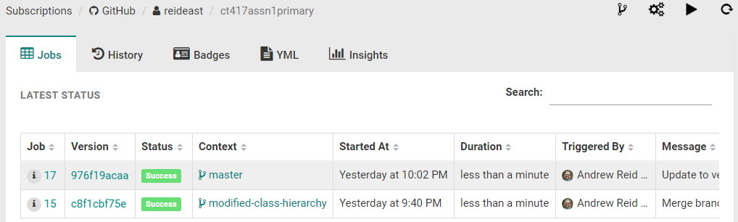

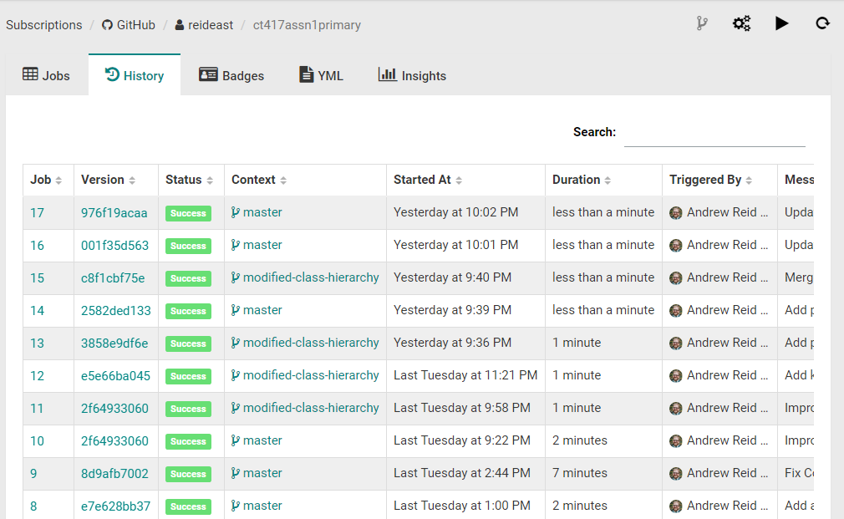

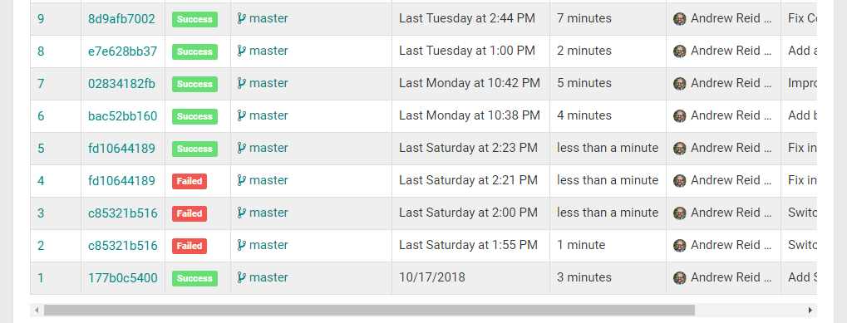

# Shippable Insights for Part A

